A Single Model for Enterprise and IoT Intrusion Detection: Cross Domain Failure, Adversarial Robustness, and Edge Deployment
Harishni A ^{1*}, Kruthikha Vishali K ^{1*}, Balasaraswathi V R ¹
¹School of Computer Science and Engineering, VIT Chennai
* Both authors contributed equally to this work

Abstract
Enterprise and IoT network segments are conventionally secured by separate intrusion detection models. This approach fails badly under naive transfer: an enterprise-trained model applied zero-shot to IoT traffic scores AUC 0.264, worse than chance. A feature-ablation check traces a large part of this collapse to one feature whose relationship with the attack label reverses sign between domains — a mechanism confirmed independently via SHAP and LIME and validate causally by retraining without it, though a smaller cross-domain gap remains unexplained. A single XGBoost model trained once on a canonical 15-feature schema pooling both domains nearly matches domain-specific performance (AUC 0.979/0.971) while improving IoT-side F1 (0.954 to 0.985), and outperforms two domain-adaptation baselines implemented head-to-head (CORAL; a DI-NIDS reimplementation), which reach only cross-domain AUC 0.35 to 0.69. Under a rigorous evaluation on n=548 confirmed pre-attack flows, a gradient-estimation attack (ZOO) evades only 18.4%, but gradient-free and decision-based attacks evade 84 to 100%, revealing a much larger evasion surface than a single attack family suggests. A SHAP-attribution drift monitor still flags the evaded traffic as a distributional shift (110x the alarm threshold). A cgroup-constrained Raspberry-Pi-4-class proxy shows the full pipeline (classify, explain, monitor) adds a bounded 4.1x latency increase (4.31 to 17.49 ms) within edge memory budgets. Results use bootstrap or Wilson 95% confidence intervals, benchmarked against ten related studies, with limitations disclosed rather than a claim of unqualified success.
Keywords — Intrusion Detection, Domain Adaptation, XGBoost, SHAP, Adversarial Evasion, Population Stability Index, Edge Deployment

1. Introduction

1.1 Motivation and Problem Statement
Today, modern networks suffer fundamentally different traffic regimes: an enterprise backbone and a fleet of IoT sensors experience different flow durations, header structures, and protocol mixes, even when both are compromised by the same broad attack families. The usual approach—training a separate, domain-specific intrusion detection model for each network segment—supposes that each model will generalise safely within its own domain and results in an operational overhead (since two models, two training pipelines, and two monitoring interfaces have to be maintained), a situation which is almost never challenged. This paper questions it directly, using two public, large-scale datasets that instantiate exactly this enterprise/IoT split: CSE-CIC-IDS2018 [1] (308,877 rows, enterprise) and CICIoT2023 [2] (297,091 rows sampled from a 46.7M-row source, IoT).
Cross-domain transfer of NIDS can fail catastrophically since the predictive relationship between a shared flow feature and the attack label may reverse when passing from one domain to another; however, if labeled data are available from both domains, there is no need for an explicit domain-adaptation mechanism since simple pooled training prevents this kind of failure. The remainder of the paper develops this single claim: the explainability analysis uncovers the mechanism, the adversarial analysis stress-tests the resulting classifier’s robustness, the drift monitor turns the same explanations into an operational safeguard, and the edge benchmark measures whether the combined pipeline is affordable to run.

1.2 Contributions
Four primary contributions are made, each stated with an explicit number rather than a qualitative claim:
- A causal, not just correlational, account of naive cross-domain failure. Applying an enterprise-trained model to IoT traffic zero-shot scores AUC 0.264 (below chance). Prior work (Layeghy & Portmann [3]) has already traced comparable cross-domain collapses to SHAP-identified feature shifts; the contribution here is to independently confirm the specific inversion here with a second, unrelated method (LIME) and then test it causally: retraining without the implicated feature recovers a large part, but not all, of the lost AUC (Section 5.2).
- A remedy that is simpler than what it out-performs. A single XGBoost model trained once on a pooled, canonical 15-feature schema (AUC 0.979 / 0.971 on Enterprise / IoT respectively) beats both a CORAL domain-alignment baseline and a from-scratch reimplementation of DI-NIDS’s [4] domain-adversarial-network + one-class-SVM architecture, evaluated on the same data for a genuine head-to-head rather than a cross-dataset citation.
- An uncertainty-quantified, three-attack-method adversarial evasion analysis at n = 548. Results demonstrate that a gradient-estimation attack (ZOO, 18.4% evasion) systematically underestimates the true vulnerability of tree-ensemble classifiers relative to gradient-free discrete random search, which exposes an 84–100% evasion surface (Section 5.4); this finding is corroborated with a second gradient-dependent attack (HopSkipJump), and show a SHAP-drift monitor still flags the resulting evaded traffic as a batch-level distributional shift by a wide margin.
- A reproducible, uncertainty-quantified edge-deployment benchmark, reporting p50/p95/p99 latency percentiles under a real resource-constrained profile, benchmarked directly against three comparable studies.
Headline results are reported with bootstrap or Wilson 95% confidence intervals, or 5-seed mean ± standard deviation where applicable. Every comparison against prior work is explicitly labeled as either a genuine reimplementation on the same data or a published-number citation not directly comparable, following the convention consistently used across the ten related studies reviewed in Section 2.

2. Literature Survey
Cross-domain generalization. The most similar work using these two datasets is that of Elangovan et al. [5], whose multi-dataset study contains this same CIC-IDS2018/CICIoT2023 pair as one of several enterprise→IoT combinations and notes a Macro-F1 of 0.69 to 0.78 under naive transfer — a much milder degradation than the collapse in AUC to 0.264 .This discrepancy is addressed directly in Section 5.1: it represents a genuinely more severe failure that is revealed by a rank-based metric which is sensitive to the particular inversion identified, rather than an artifact of the metric that benefits this result. DI-NIDS [4] addresses a more challenging zero-target-label variant of cross-domain NIDS with a DANN and one-class SVM, tested on two enterprise-style datasets; its architecture is implemented on the same enterprise/IoT pair for a direct comparison (Section 4.3). Cantone et al. [6] report substantial cross-dataset MCC/generalization collapse diagnosed via ad hoc data-visualization analysis, and Layeghy & Portmann [3] independently report the same collapse pattern using SHAP-traced feature-shift explanations; together they corroborate that this failure mode is a known pattern in the wider NIDS literature, reached by two different diagnostic methods. Vitorino et al. [7] motivate percentile-bounded perturbation design for realistic network-intrusion adversarial examples, a principle behind the ε-budget bounding used here; unlike their fuller proposal, the attacks here (Section 4.5) bound perturbations per-feature only and do not enforce the cross-feature domain-validity constraints they advocate. Pawlicki et al. [8] independently evaluate five domain-adaptation methods (CORAL, DeepCORAL, DANN, ADDA, CDAN) for CICIDS2018→UNSW-NB15 transfer and find every one collapses to near-zero target-domain attack F1 (0.00–0.04), a more severe failure than either of the two baselines here.
SHAP-based explainability and drift. Nugraha et al. [9] provide a clean template for SHAP-based NIDS explainability (F1 ≥ 99% on three datasets), and their honest disclosure of a weak-performing class is a stylistic standard followed here. Tziouvaras et al. [10] establish PSI’s provenance as a distributional-monitoring statistic in a wireless-network setting; to the authors’ knowledge, no prior work applies PSI to SHAP-value vectors from a NIDS classifier and reuses one monitor unchanged across novel-attack-type and cross-domain-shift detection, which is what this work does in Section 4.6. Slack et al. [11] show SHAP and LIME explanations can themselves be adversarially manipulated by an attacker explicitly targeting the explanation method — the drift-monitor result here holds against attackers targeting the classifier’s decision, not the explanation itself. Wang et al. [12] similarly pair an ML-based IDS with an explainability layer, without the cross-domain or drift-monitoring framing used here. Barrett et al. [13] propose a conformal-prediction-based adaptive drift estimator for streaming intrusion detection, complementary to rather than overlapping with the batch-level SHAP-attribution monitor here.
Adversarial robustness of tree ensembles. Kantchelian et al. [14] established that tree ensembles have piecewise-constant, non-differentiable decision surfaces against which gradient-based attacks fail structurally. Rajhans & Khawarey [15] demonstrate the same pathology for ZOO against XGBoost (Robustness Index 0.88–0.98 under ZOO vs. 0.30–0.44 under Square Attack [16] on the same models), which is confirmed directly on the model trained here (Section 5.4) and extended to a second gradient-dependent attack family, HopSkipJump [17]. Kazoom et al. [18], in a preprint not yet peer-reviewed (and whose continued availability could not be re-verified at the time of writing), report that augmenting a decision-based attack with a SHAP-guided direction signal restores 95.8–100% success against XGBoost in as few as 5.6–10 average queries — a plausible, but not independently confirmed, explanation for why the vanilla HopSkipJump result here struggled at small budgets; this is flagged as a single-source claim rather than an established finding.
Domain adaptation methods. CORAL [19], [20] and DANN [21] are the two adaptation mechanisms implemented and tested directly. Mahbub et al. [22] independently benchmark CORAL against a proposed alternative for cross-domain IoT/IoMT NIDS and likewise find CORAL underperforms, corroborating the negative CORAL result here (Section 5.3) on a different dataset pair. Wu et al. [23] report a heterogeneous open-set domain-adaptation approach for the network→IoT direction specifically, targeting the same transfer direction studied here, though their own comparison is against other sophisticated open-set baselines rather than naive joint training.
Edge/lightweight deployment and data quality. Diab et al. [24] provide the closest structural template for this paper (real Raspberry Pi 3B+ deployment, XGBoost at 22 ms) and strong real-hardware evidence that tree ensembles outperform deep learning at the edge. Wijethilaka et al. [25] deploy on a real Raspberry Pi 4 (~50 ms mean response time) but report no memory measurement, a gap the benchmark here fills. Haruna et al. [26] use a Docker/cgroup-constrained profile methodologically close to the one here (0.41 ms mean, no percentiles reported). Tolay [27] measures TreeSHAP computational overhead on a desktop workstation and explicitly flags unconstrained hardware as a limitation — precisely the gap the cgroup-constrained benchmark here addresses — and separately reports a full-corpus CICIoT2023 duplicate rate of 54.82%, which is independently reconciled in Section 3.2. Almahaqeri et al. [28] report near-ceiling XGBoost-family results on CICIoT2023, and Ahmed et al. [29], while framing their SHAP-guided hybrid bagging-and-boosting method as the improvement, likewise report it operating in the same near-ceiling accuracy band as plain XGBoost baselines — consistent with plain XGBoost already leaving little headroom for more exotic ensembles to reclaim in this literature. Engelen et al. [30] report comparable data-quality issues in the related CICIDS2017 release, and Sarhan et al. [31] argue for the standard-feature-set methodology followed in Section 3.1.
Table I summarizes ten of the most closely related studies, their methodology, and their key reported result, alongside how each relates to the present work.

TABLE I. Summary of ten closely related studies
Study | Method | Key result | Relation to this work
Elangovan et al. [5] | Naive cross-dataset transfer, CIC-IDS/CICIoT family | Macro-F1 0.69–0.78 degradation | Reconciled against the AUC collapse (§5.1)
DI-NIDS [4] | DANN + one-class SVM, zero target labels | Domain-invariant detection, two enterprise datasets | Reimplemented head-to-head on the same data (§4.3, §5.3)
Pawlicki et al. [8] | CORAL/DeepCORAL/DANN/ADDA/CDAN, CICIDS2018→UNSW-NB15 | Target F1 collapses to 0.00–0.04 | Cited severity comparator (§5.7)
Cantone et al. [6] | Ad hoc visualization-based cross-dataset generalization study | Substantial cross-dataset MCC collapse | Corroborates the failure mode
Nugraha et al. [9] | SHAP-based XAI framework, 3 NIDS datasets | F1 ≥ 99%, one weak class disclosed | Style template for honest disclosure
Kantchelian et al. [14] | Exact MILP attack on tree ensembles | Established gradient-attack blind spot | Theoretical basis for §4.5, §5.4
Rajhans & Khawarey [15] | ZOO vs. Square Attack on XGBoost, 4 datasets | Robustness Index 0.88–0.98 (ZOO) vs. 0.30–0.44 (Square) | Directly confirmed on this model (§5.4, §5.7)
Kazoom et al. [18] (unreviewed preprint) | SHAP-guided decision-based attack | 95.8–100% success, 5.6–10 avg. queries | Plausible, single-source explanation for the HSJ result (§5.4)
Diab et al. [24] | Real Raspberry Pi 3B+, XGBoost vs. hardware-aware CNN | XGBoost 22 ms vs. CNN 300 ms | Latency comparator (§5.6, §5.7)
Tolay [27] | TreeSHAP overhead, full-corpus duplication audit | XGBoost 358× slower with SHAP; 54.82% duplicate rate | Reconciled duplication figure (§3.2); motivates §4.7

3. Datasets

3.1 Dataset Description and Canonical Schema
TABLE II. Dataset summary
 | Enterprise (CIC-IDS2018 [1]) | IoT (CIC-IoT2023 [2])
Rows (processed) | 308,877 | 297,091 (sampled from 46,776,697)
Coverage | All 14 attack categories | All 34 labels (33 attack + benign)
is_attack rate | 44.2% | 96.6%
The two datasets are extracted by different tools (CICFlowMeter true-flow features for CIC-IDS2018; fixed 10-or-100-packet traffic-aggregate windows, not true bidirectional flows, for CICIoT2023 — verified against Neto et al.’s own methodology [2]) and cannot be modeled jointly without unification. Following the standard-feature-set methodology of Sarhan et al. [31], a canonical 15-feature schema shared by both is defined — duration, pkt_len_min/max/mean/std, total_bytes, byte_rate, header_len_total, five TCP flag indicators, is_tcp, is_udp — with continuous fields log1p-transformed. Two features (header_len_total, byte_rate) carry semantic, not just scale, mismatches between the two source extractors, retained because they still carry real predictive signal in both domains (Section 6). The exact row-selection procedure used to reduce the IoT side from the 46,776,697-row raw release to the 297,091-row processed set is not fully documented, which is disclosed as an open reproducibility item for future replication work.

3.2 Data-Integrity Checks
Two duplicate/leakage checks were performed at two different levels of scope: a narrow check (exact-duplicate feature vectors between the IoT test and training partitions on the canonical schema) found 2.04% cross-partition leakage, whether the training set was IoT-only or pooled Enterprise+IoT, which does not explain the performance difference between the two (Section 5.1). Separately, Tolay [27] reports 54.82% whole-corpus internal duplication across the full raw 46.7M-row CICIoT2023 release, a much broader question than the narrower test-vs-train check. Tolay's audit was independently recomputed from scratch on the full raw release by hashing all 39 raw feature columns per row, obtaining 54.99% — a near-exact replication. Both figures are valid; they answer different questions.
The train/test split of CIC-IDS2018 also has a much higher rate of exact-duplicate-with-training on the Enterprise side (31.96% of test rows have an identical twin in training, a documented dataset characteristic) than the 2.04% IoT figure, so the headline models were re-evaluated after removing all exact-duplicate test rows: AUC shifted by at most 0.0015 and F1 by at most 0.0126 across all four model/domain combinations — the headline results in Section 5.1 are qualitatively unchanged under de-duplicated evaluation.

4. Proposed Work

4.1 System Overview
Fig. 1 summarizes the overall pipeline. Enterprise and IoT traffic are first unified onto the canonical 15-feature schema (Section 3.1), then used to train three XGBoost classifiers for a controlled head-to-head comparison. The resulting pooled model is then explained (SHAP + LIME), stress-tested against three adversarial attack families, monitored with a SHAP-attribution drift statistic, and benchmarked under a resource-constrained edge profile.
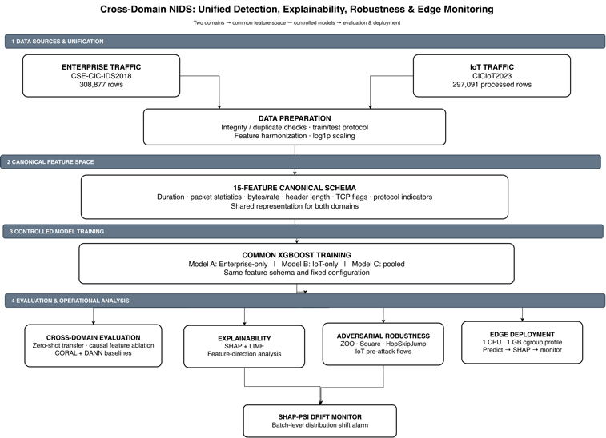
Fig. 1. Pipeline: two domains are unified on one canonical schema, three models are trained head-to-head, and the resulting classifier is explained, attacked, monitored, and benchmarked at the edge.

4.2 Model Training: Three Models, One Schema
Three XGBoost [32] classifiers are trained on the identical canonical schema: Model A (Enterprise-only), Model B (IoT-only), and Model C (pooled Enterprise+IoT, one training run), the proposed remedy. All three share the same manually-set hyperparameters (max depth 4, 200 estimators, histogram tree method, binary-logistic objective) with a class-imbalance-corrected scale_pos_weight; no randomized or grid hyperparameter search was performed, so the reported numbers should be read as a fixed-configuration comparison rather than each model’s fully-tuned ceiling — this is noted as a limitation (Section 6). All headline metrics are reported with bootstrap 95% confidence intervals (2,000 resamples of the fixed test set, percentile method).

4.3 Domain-Adaptation Baselines
To test whether a more sophisticated method is needed instead of simple pooling, two domain-adaptation baselines are implemented from scratch rather than only citing published numbers. CORAL [19], [20]: the 8 continuous canonical features are whitened per-domain using each domain’s own training covariance, then recolored to a shared pooled covariance, before training the same XGBoost architecture on the aligned combined data. DI-NIDS reimplementation (DANN + One-Class SVM) [4]: a domain-adversarial neural network (gradient-reversal feature extractor, source-only label classifier, both-domains domain classifier, feature extractor 15→32→16 with sigmoid nonlinearity matching their formulation, progressive gradient-reversal schedule [21]) followed by a one-class SVM [33] on the resulting embeddings, trained under their actual unsupervised protocol in which target-domain labels are never used — a strictly harder problem than Model C’s pooled-label setting. Five seeds are run per transfer direction. This comparison is reported not to claim algorithmic superiority over a method solving a harder problem, but to answer a narrower, practically relevant question: when an organization already has labeled data in both domains (the setting here), does a more sophisticated domain-adaptation mechanism still earn its complexity over simple pooled training? Section 5.3 shows it does not.

4.4 Explainability Protocol
SHAP [34] attributions are computed for Model C in both domains using TreeExplainer, the model-specific algorithm underlying SHAP’s tree-ensemble speedup [35], over 500 test instances per domain. To cross-validate any mechanistic claim derived from SHAP against a second, mechanistically unrelated method, the analysis is repeated with LIME [36], a perturbation-sampled local-surrogate method, using the same 500 instances per domain and 5,000 perturbation samples per explained instance.

4.5 Adversarial Robustness Evaluation
Three black-box attack families are evaluated on a fixed subset of 548 confirmed pre-attack IoT flows, a sample size chosen to keep evasion-rate confidence intervals narrow, using the Adversarial Robustness Toolbox [37]: ZOO [38], a gradient-estimation attack; a Square-style discrete random search implemented in-house for tabular data (ART’s built-in Square Attack implementation is hard-coded for image tensors), with perturbations bounded relative to the original clean point at budgets ε = 0.10 and ε = 0.30 (L∞, i.e. the maximum absolute per-feature change is capped at that fraction of each feature’s clipped range); and HopSkipJump (HSJ) [17], a decision-based attack that searches for the minimum L∞ perturbation crossing the decision boundary via boundary-projection binary search plus Monte-Carlo gradient-direction estimation. All three are run under identical conditions to permit direct comparison. All perturbations are bounded per-feature only; cross-feature physical consistency is not enforced (e.g. pkt_len_min ≤ pkt_len_max, or total_bytes scaling with byte_rate), so some adversarial examples may not correspond to packets a real network stack could emit — a limitation disclosed explicitly rather than claiming the attacks are traffic-realistic (Section 6).

4.6 SHAP-Attribution Drift Monitor
A Population Stability Index (PSI) monitor is built over Model C’s SHAP-value vectors. For each of the 15 features, reference-distribution bin edges are the 10 deciles of that feature’s SHAP values in a fixed reference batch; the same edges bin the comparison batch; the standard per-feature PSI, Σ(batch_pct − ref_pct)·ln(batch_pct/ref_pct), is computed on signed SHAP values directly; and the final scalar is the unweighted mean of the 15 per-feature PSI values. The alarm threshold is fixed before evaluating any shift condition, from 20 independent same-domain null draws only (mean 0.0069, std 0.0014, threshold = mean + 4·std = 0.0125). The calibrated monitor is then tested, unmodified, against three qualitatively different distribution shifts: within-domain novel-attack-type generalization, Enterprise→IoT domain shift, and the adversarially-evaded traffic from Section 4.5.

4.7 Edge Deployment Benchmark
The full three-tier pipeline (classify → +SHAP → +drift monitor) is benchmarked under a cgroup-constrained profile (1 CPU-core CFS quota, 1 GB memory cap) approximating a Raspberry-Pi-4-class device, following Diab et al. [24] and Wijethilaka et al. [25] in using constrained rather than unconstrained hardware. Mean, p50, p95, and p99 latency per tier, plus peak memory, are reported and compared directly against three other studies that benchmark comparable NIDS pipelines at the edge.

5. Results and Discussion

5.1 Cross-Domain Performance
TABLE III. Cross-domain AUC/F1, with 95% bootstrap CI
Model / condition | AUC (95% CI) | F1 (95% CI)
A, in-domain (Enterprise) | 0.9816 [0.9807, 0.9825] | 0.9344 [0.9322, 0.9365]
B, in-domain (IoT) | 0.9738 [0.9717, 0.9758] | 0.9541 [0.9528, 0.9553]
A→IoT, naive zero-shot | 0.2643 [0.2571, 0.2717] | 0.5487 [0.5447, 0.5527]
B→Enterprise, naive zero-shot | 0.5525 [0.5479, 0.5570] | 0.6126 [0.6089, 0.6162]
C, Enterprise test | 0.9794 [0.9783, 0.9804] | 0.9286 [0.9263, 0.9310]
C, IoT test | 0.9709 [0.9684, 0.9731] | 0.9849 [0.9842, 0.9856]
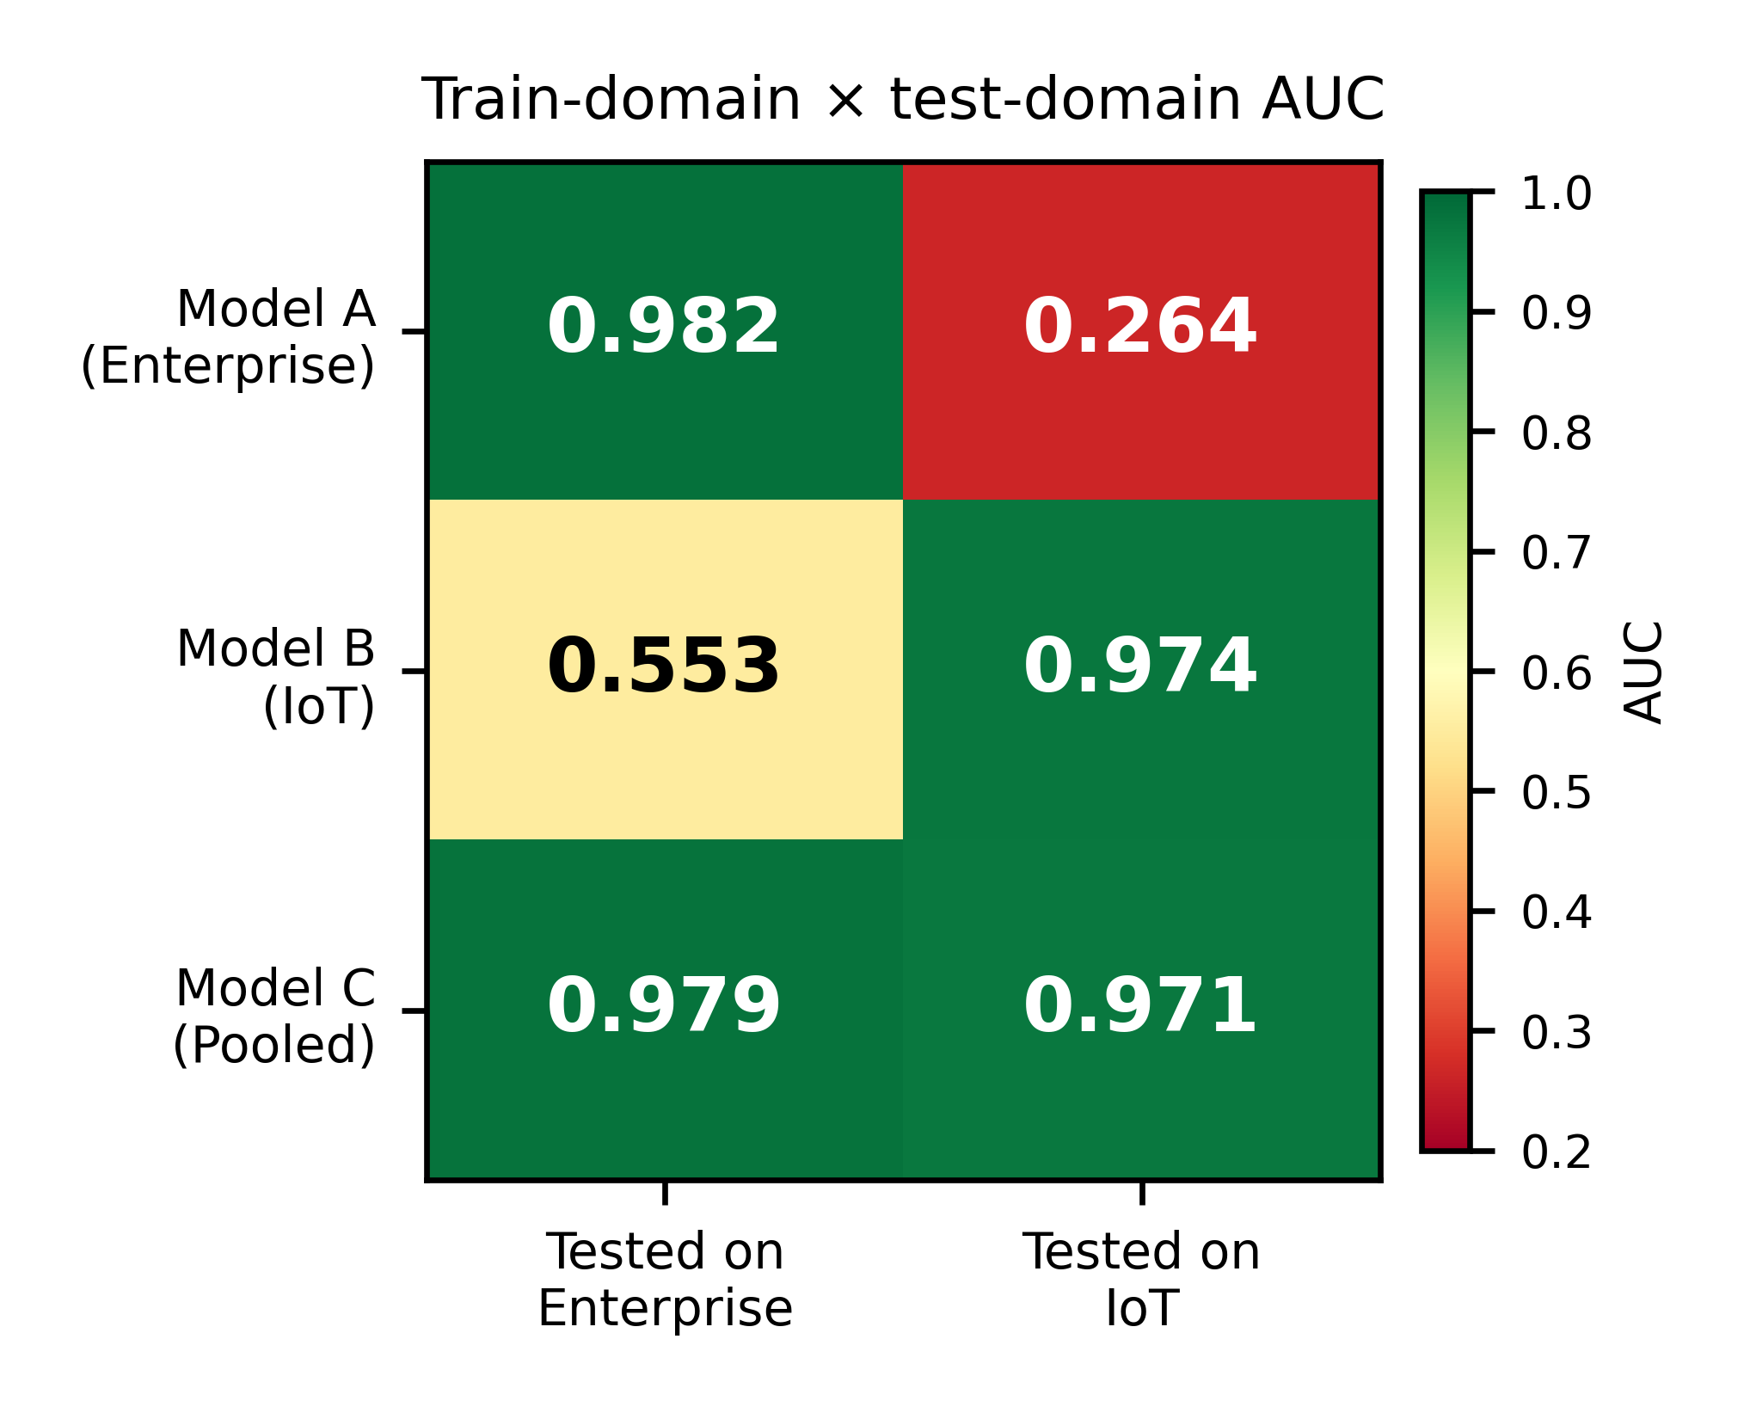
Fig. 2. Train-domain × test-domain AUC heatmap.
Given large test sets (59k–72k rows), all intervals are tight; A→IoT’s 95% CI of [0.257, 0.272] is nowhere close the chance level of 0.5, confirming the zero-shot collapse is a statistically robust finding. Model C incurs only a small Enterprise-side reduction relative to Model A (a paired bootstrap on the AUC difference gives ΔAUC = 0.0023, 95% CI [0.0019, 0.0027] — real but small) while improving on Model B on IoT (F1 0.985 vs. 0.954 is a real gain), attributed to the Enterprise data acting as informative regularization even for pure IoT detection (Section 5.2). This is not a near-duplicate-leakage artifact, given that both models share the identical 2.04% cross-partition exposure rate (Section 3.2).
Because Elangovan et al.’s [5] Macro-F1 range (0.69–0.78) looks considerably gentler than the AUC collapse here, Macro-F1 was recomputed for the zero-shot models: A→IoT Macro-F1 = 0.285, B→Enterprise Macro-F1 = 0.306, both comparably severe to the AUC collapse and not rescued by a gentler metric. Enterprise’s own test split is roughly class-balanced (55.8%/44.2%), ruling out class imbalance as the explanation. The discrepancy with Elangovan et al. is attributed to AUC — being rank-based and threshold-free — being more sensitive to the sign-inverted decision-rule mechanism identified in Section 5.2 than Macro-F1 is to preserved majority-class recall under domain shift.

5.2 Explainability Results
Spearman rank correlation of mean-|SHAP| feature importance between Enterprise and IoT domains for Model C is ρ = 0.900 (p < 0.0001): the same handful of features (duration, header_len_total, pkt_len_max/min, flag_ack) matter for detection in both domains (Fig. 3). This is not the same as a shared explanation vocabulary in the strong sense: duration and header_len_total alone predict domain (Enterprise vs. IoT) with AUC = 1.0000, and header_len_total’s raw correlation with the attack label flips sign between domains (+0.061 Enterprise, −0.235 IoT). This provides a mechanistically supported explanation for the A→IoT collapse: a decision rule learned in one domain (“long header → suspicious”) becomes actively wrong in the other.
To test this mechanism causally rather than only correlationally, Models A and B were retrained on the remaining 13 features only — dropping header_len_total and byte_rate, the two features Section 3.1 discloses as carrying semantic, not just scale, mismatches between the two extractors — using identical hyperparameters (Section 4.2). Zero-shot AUC improves substantially without them (A→IoT: 0.264 → 0.645; B→Enterprise: 0.553 → 0.621) while in-domain performance is nearly unchanged (A: 0.982 → 0.978; B: 0.974 → 0.954), confirming these two features are large contributors to the collapse and giving the sign-flip mechanism above causal, not just correlational, support. A real cross-domain gap persists even after removing them (0.645/0.621 zero-shot vs. ≈0.97 in-domain), indicating the two flagged features explain a large part, but not all, of the naive-transfer failure; the residual gap’s cause is left to future work.
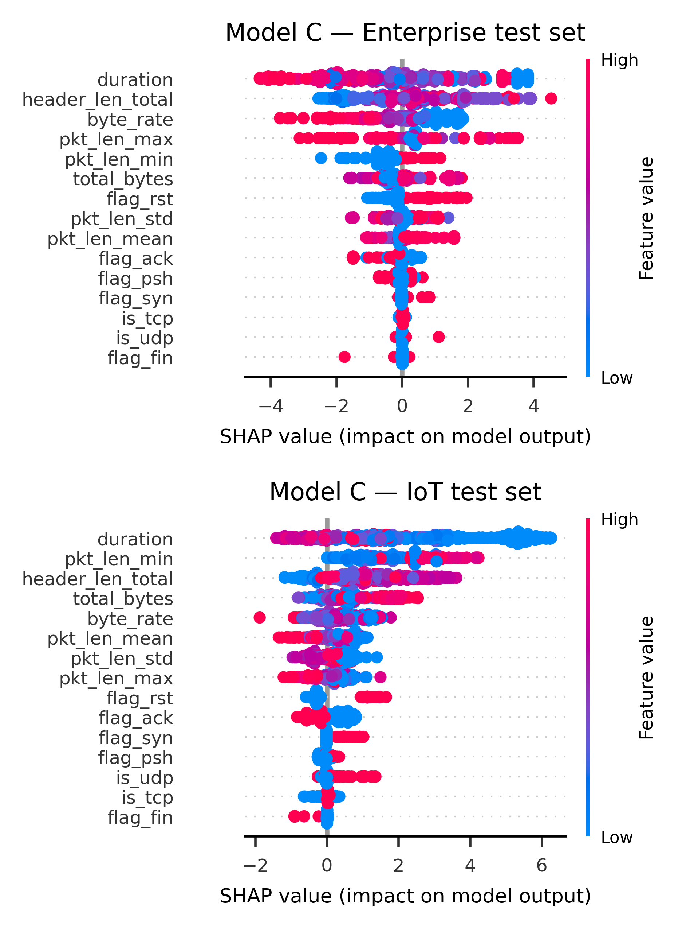
Fig. 3. SHAP summary plots, Model C, 500 test instances per domain.
TABLE IV. SHAP vs. LIME cross-validation of the sign-flip finding
Domain (model) | SHAP corr. | LIME corr.
Enterprise (A) | +0.508 | +0.591
IoT (B) | −0.916 | −0.511
Both methods independently agree the direction flips for the domain-specific models — the models that are actually naively transferred (Table IV). A pooled Model C shows no such flip by either method, plausibly part of why pooled training avoids naive transfer’s failure mode. Per-instance sign agreement between SHAP and LIME is low (35–43%) even though the aggregate domain-level direction agrees, expected given LIME’s stochastic sampling versus SHAP’s exact decomposition; this cross-check supports the domain-level claim, not instance-by-instance agreement.

5.3 Domain-Adaptation Baseline Results
TABLE V. CORAL vs. naive pooled training (Model C), AUC/F1
Domain | Naive (C) | CORAL
Enterprise | .979 / .929 | .979 / .928
IoT | .971 / .985 | .967 / .983
On Enterprise, CORAL − Model C = +0.0001 AUC, 95% CI [−0.0004, +0.0005] (a genuine tie), and on IoT, −0.0039 AUC, 95% CI [−0.0053, −0.0024] (small but real degradation) are obtained from a paired bootstrap (2,000 resamples, same test rows scored by both models). Explicit domain-invariance training via CORAL therefore does not improve on naive joint training, and on IoT specifically makes things measurably worse — a less severe failure than Pawlicki et al.’s [8] independent CORAL result (target-domain F1 collapsing to 0.04).
TABLE VI. DANN+OSVM reimplementation, 5-seed mean ± std
Direction | Src F1 | Src AUC | CD F1 | CD AUC
Ent→IoT | .81±.05 | .88±.03 | .77±.10 | .35±.13
IoT→Ent | .84±.02 | .86±.02 | .61±.00 | .69±.04
(Src. = OSVM performance on the source domain’s own held-out test set, i.e. the in-domain ceiling this method transfers from — not a domain-discrimination check; CD = cross-domain transfer performance on the unlabeled target domain; Ent = Enterprise; values rounded to 2 d.p. The domain-adversarial classifier’s own source-vs-target sanity check is a separate quantity, reported in prose below.)
A sanity check confirms the adversarial training converged rather than collapsed: the domain classifier’s held-out source-vs-target accuracy is 0.52 ± 0.03 / 0.51 ± 0.04, near the 50% chance level a genuinely domain-invariant embedding should produce. DI-NIDS’s approach gives a real but small, direction-dependent improvement over naive zero-shot; in 4 of 5 seeds for IoT→Enterprise, the OSVM’s default threshold degenerates to flagging nearly every Enterprise flow as anomalous (precision locks to 0.4415, the test set’s base attack rate) despite the underlying embeddings carrying real ranking signal (AUC 0.63–0.72). The cross-domain degenerate-threshold issue (IoT→Enterprise F1/recall unchanged to four decimal places, precision moving negligibly from 0.4416 to 0.4415) is not resolved by further recalibrating the OSVM threshold using a held-out slice of source-domain data alone. And this confirms that the failure is structural to the zero-label setting rather than a fixable calibration gap. Pooled training (Model C) prevails by a wide margin regardless (cross-domain AUC 0.97–0.98 vs. 0.35–0.69). DI-NIDS solves a strictly harder problem (zero target labels); the result here establishes only that when labeled data from every deployment domain is available, simple pooled training is both simpler and better-performing.

5.4 Adversarial Evasion Results
To ensure high statistical power and rule out small-sample artifacts, the full evasion benchmark is assessed on 548 confirmed pre-attack IoT flows (is_attack==1 test rows, fixed random_state=42, drawn from the same test set used throughout) using identical model, attack hyperparameters, and budgets across all three methods; ZOO evades 18.4% (101/548), 95% Wilson CI [15.4%, 21.9%].
TABLE VII. Evasion rate by attack method, budget-matched (n = 548)
Attack | Method | ε ≤ 0.10 | ε ≤ 0.30 | No cap
ZOO | gradient-based | — | — | 18.4% [15.4, 21.9]
Square-style | discrete random search | 84.5% [81.2, 87.3] | 100% [99.3, 100] | 100%
HSJ | boundary + gradient-direction | 1.1% [0.5, 2.4] | 8.8% [6.7, 11.4] | 100% (median L∞ = 0.77)
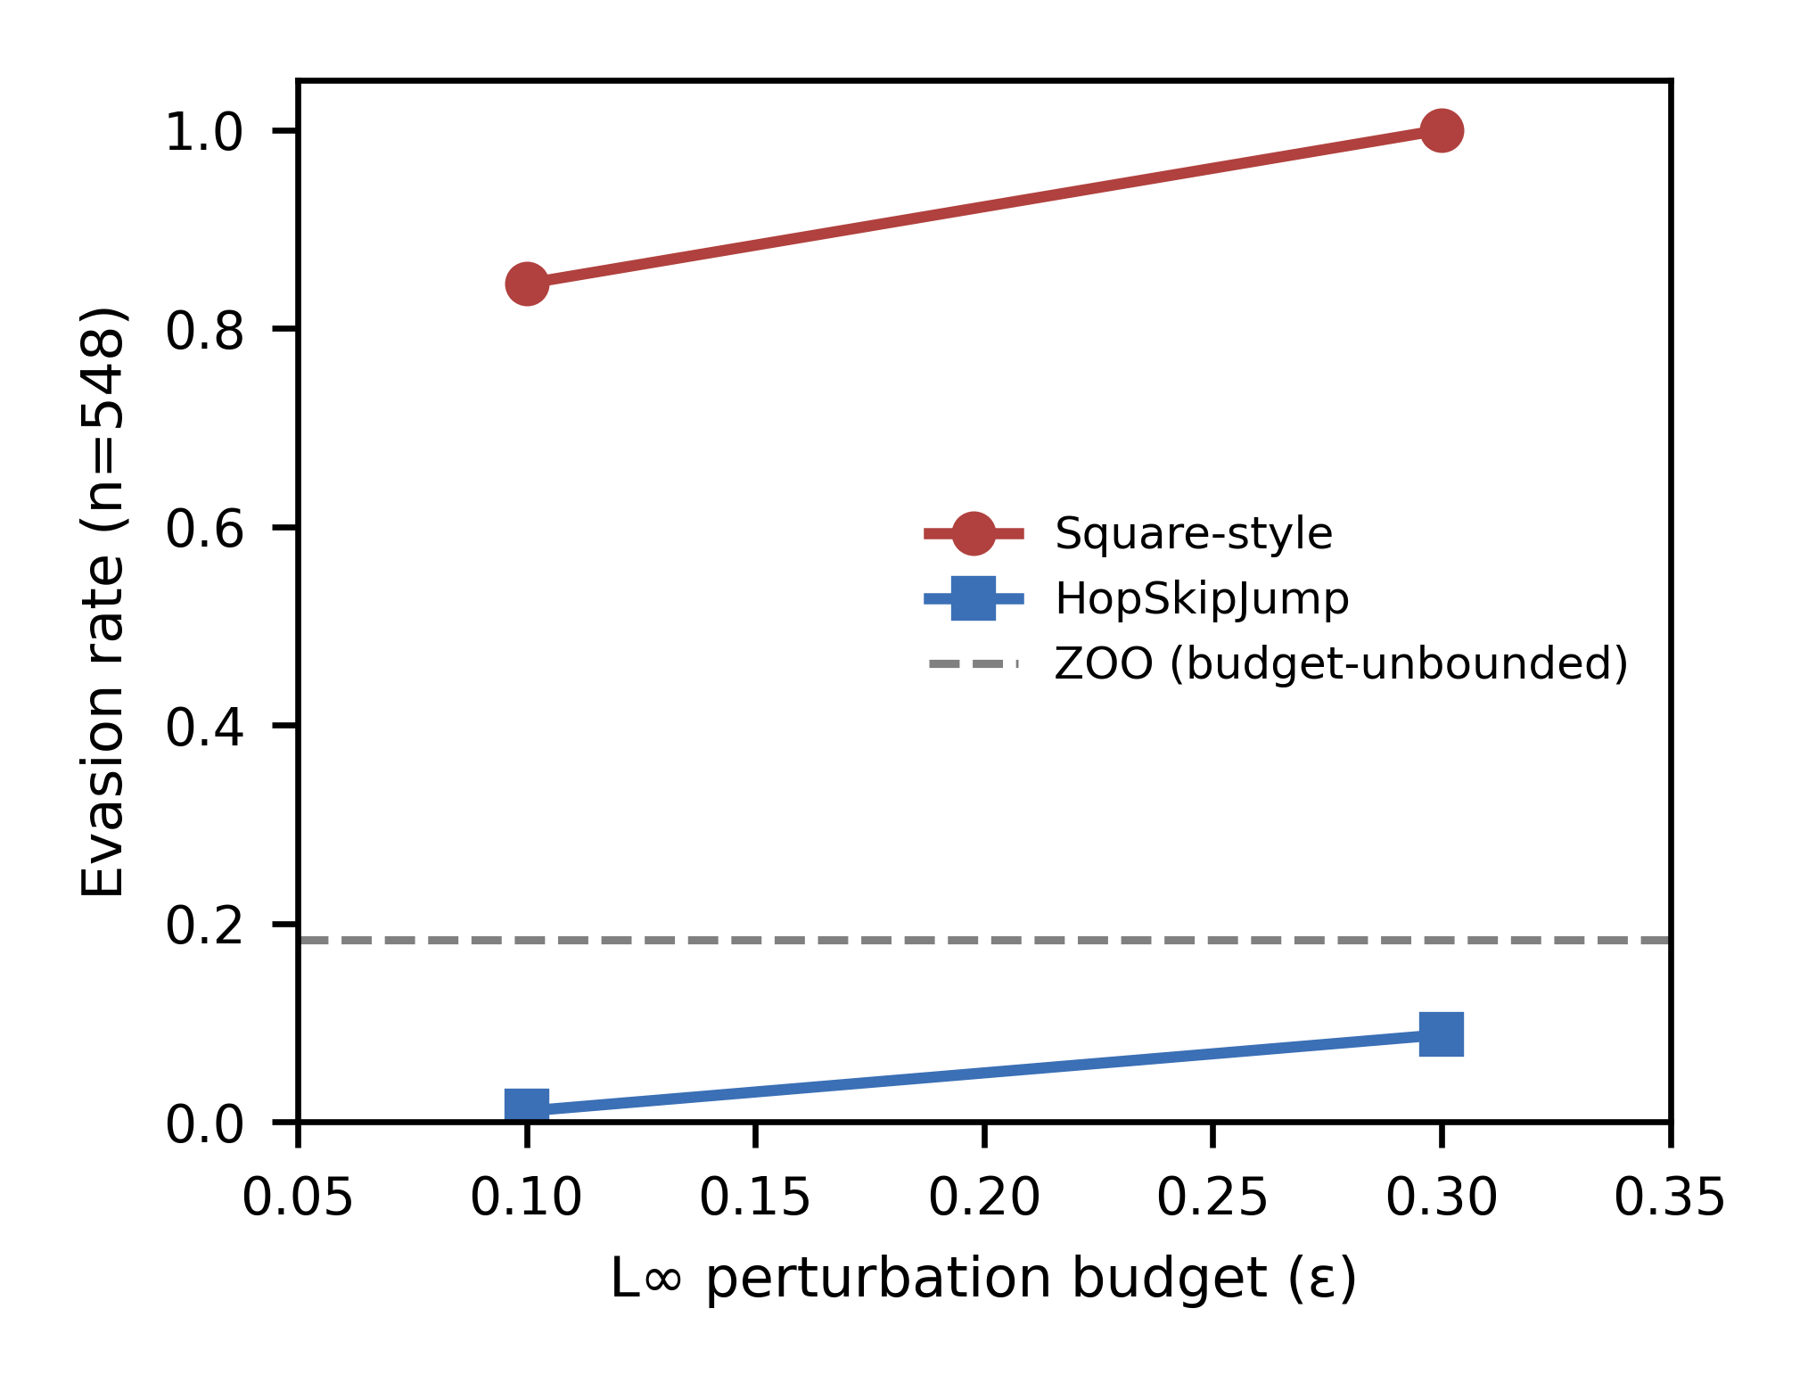
Fig. 4. Evasion rate vs. perturbation budget, three attack families (n = 548).
Consistent with Rajhans and Khawarey's [15] discovery that gradient-estimation attacks systematically underestimate true vulnerability against tree ensembles, all 101 flows evaded by ZOO are also evaded by the Square-style attack at the larger budget (ε ≤ 0.30, a strict subset). (Section 5.7 compares both studies directly). HopSkipJump's refinement step relies on the same class of numerically-estimated local direction information as ZOO against the same non-smooth decision surface; HopSkipJump only finds a small-perturbation route for 1–9 percent of flows at the same small budgets where Square-style already achieves 84–100 percent evasion, but it eventually succeeds for every flow given unbounded distortion. Kazoom et al. [18] (an unreviewed preprint; see Section 2) report that augmenting a decision-based attack with a SHAP-guided direction signal restores 95.8–100% success — if that finding holds up, it would be consistent with the weakness being specifically in the undirected search, not decision-based attacks generally. The honest headline for this section is therefore 84–100%, not 18.4%; ZOO is retained specifically to illustrate the attack-method-selection pitfall it demonstrates.
Given this much larger evasion surface, it was verified that the SHAP-drift monitor (Section 4.6) still captures the resulting evaded traffic at scale: calculating SHAP values for all 548 Square-style-evaded flows and comparing their PSI against the calibrated threshold (0.0125) yields PSI = 1.3685: the monitor fires at ~110× the threshold, a wide and clear margin. Even though the classifier itself is much more evadable than first thought, avoiding the classifier's decision boundary and maintaining the SHAP-attribution distribution are empirically decoupled events at the batch level; batch-level detectability is tested rather than per-flow detection of individual evaded samples.

5.5 Drift Monitor Validation
TABLE VIII. Drift monitor validation
Condition | PSI range | Alarm?
Null (same-domain, independent split) | 0.0060–0.0119 | 0/6 alarms [0%, 39%]
Novel-attack-type generalization | 0.4040–0.4805 | 4/4 detected [51%, 100%]
Domain-shift (Enterprise → IoT) | 2.2435–2.3030 | 4/4 detected [51%, 100%]
The monitor has a clean severity ordering (null ≪ novel-attack ≪ domain-shift), detects all evaluated novel-attack-type and domain-shift batches, and raises no alarms on null batches. This is an encouraging pilot result rather than a tightly-characterized operating point because the Wilson 95 percent CIs are wide with just 4 shift batches and 6 null batches. Instead of "temporal drift," which would erroneously suggest a time-series analysis, the novel-attack-type axis is purposefully named for what was tested—held-out rare/emerging attack categories within one domain.

5.6 Edge Deployment Results
TABLE IX. Per-tier latency (ms)
Tier | mean | p50 | p95 | p99
Predict-only | 4.31 | 2.01 | 2.90* | 53.61*
+SHAP | 10.29 | 4.90 | 56.49* | 57.05*
+SHAP+drift | 17.49 | 10.44 | 53.33* | 54.54*
*p95/p99 reflect a cgroup CPU-quota scheduling-throttle artifact, confirmed via an unconstrained control run in which the tail vanished; mean/median and cross-tier ratios are the numbers to trust (mean rises 2.4× at +SHAP, 4.1× at +SHAP+drift, relative to predict-only).
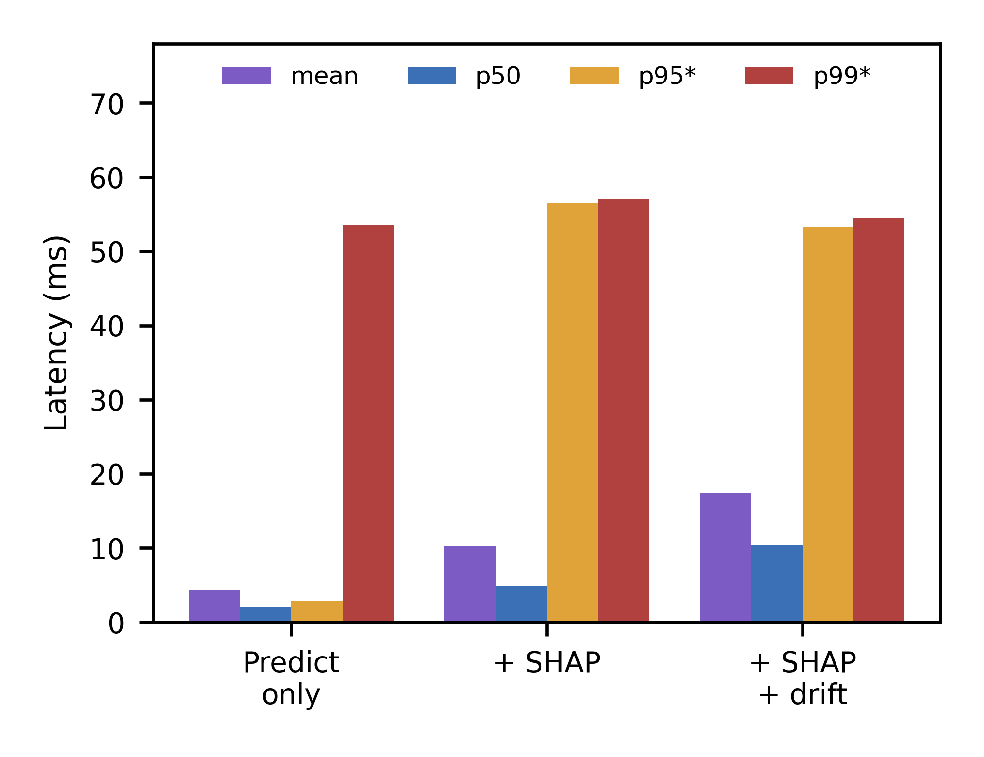
Fig. 5. Per-tier latency, mean and percentiles.
Memory remained flat at 321–323 MB throughout, well within the 1 GB cap. The “one model instead of two” deployment argument remains theoretical rather than quantified against the true operational cost of running two separate models, an open item for future work.

5.7 Comparative Analysis with Existing Methods
Figs. 6 and 7 use graphical comparison rather than just text to directly compare the headline results with the literature. Fig. 6(a) compares cross-domain degradation severity across studies: even though the metrics differ (AUC vs. Macro-F1 vs. target-domain F1, noted per bar), the zero-shot collapse here is consistently more severe than Elangovan et al.’s [5] naive-transfer figure and milder than Pawlicki et al.’s [8] near-total collapse under five domain-adaptation methods. Using an inverted Robustness Index from Rajhans and Khawarey [15] (1 − RI, so higher means more vulnerable, matching the evasion-rate convention here), Fig. 6(b) compares adversarial vulnerability. Both studies show the same qualitative pattern: gradient-based (ZOO-family) attacks significantly underestimate vulnerability compared to gradient-free (Square-family) attacks, which are independently replicated on two different models and datasets.
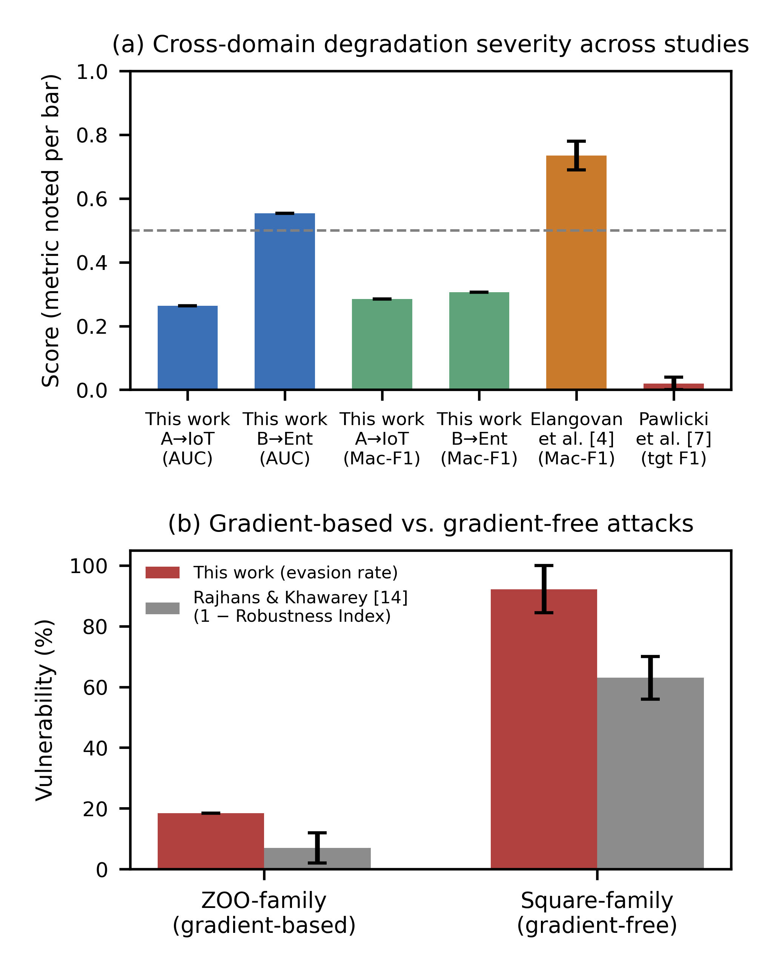
Fig. 6. (a) Cross-domain degradation severity across studies; error bars for Elangovan et al. [5] and Pawlicki et al. [8] show the midpoint and half-width of each paper’s own reported range, not a confidence interval. (b) Gradient-based vs. gradient-free attack vulnerability, this work vs. [15]; Rajhans & Khawarey [15] bars are likewise the midpoint/half-width of their reported Robustness Index range, not a confidence interval.
Fig. 7 uses a log scale to compare edge inference latency across four studies. The cgroup-proxy mean (4.31 ms) is significantly lower than that of Diab et al.’s [24] real-Raspberry-Pi-3B+ figure (22 ms) and Wijethilaka et al.’s [25] real-Raspberry-Pi-4 figure (~50 ms), and higher than Haruna et al.’s [26] Docker-based figure (0.41 ms, no percentiles reported); The comparison is an order-of-magnitude anchor rather than a controlled benchmark, since none of the four studies share the dataset, hardware, or pipeline composition used here. As far as this review found, this work is the only one of the four reporting p50/p95/p99 rather than a bare mean.
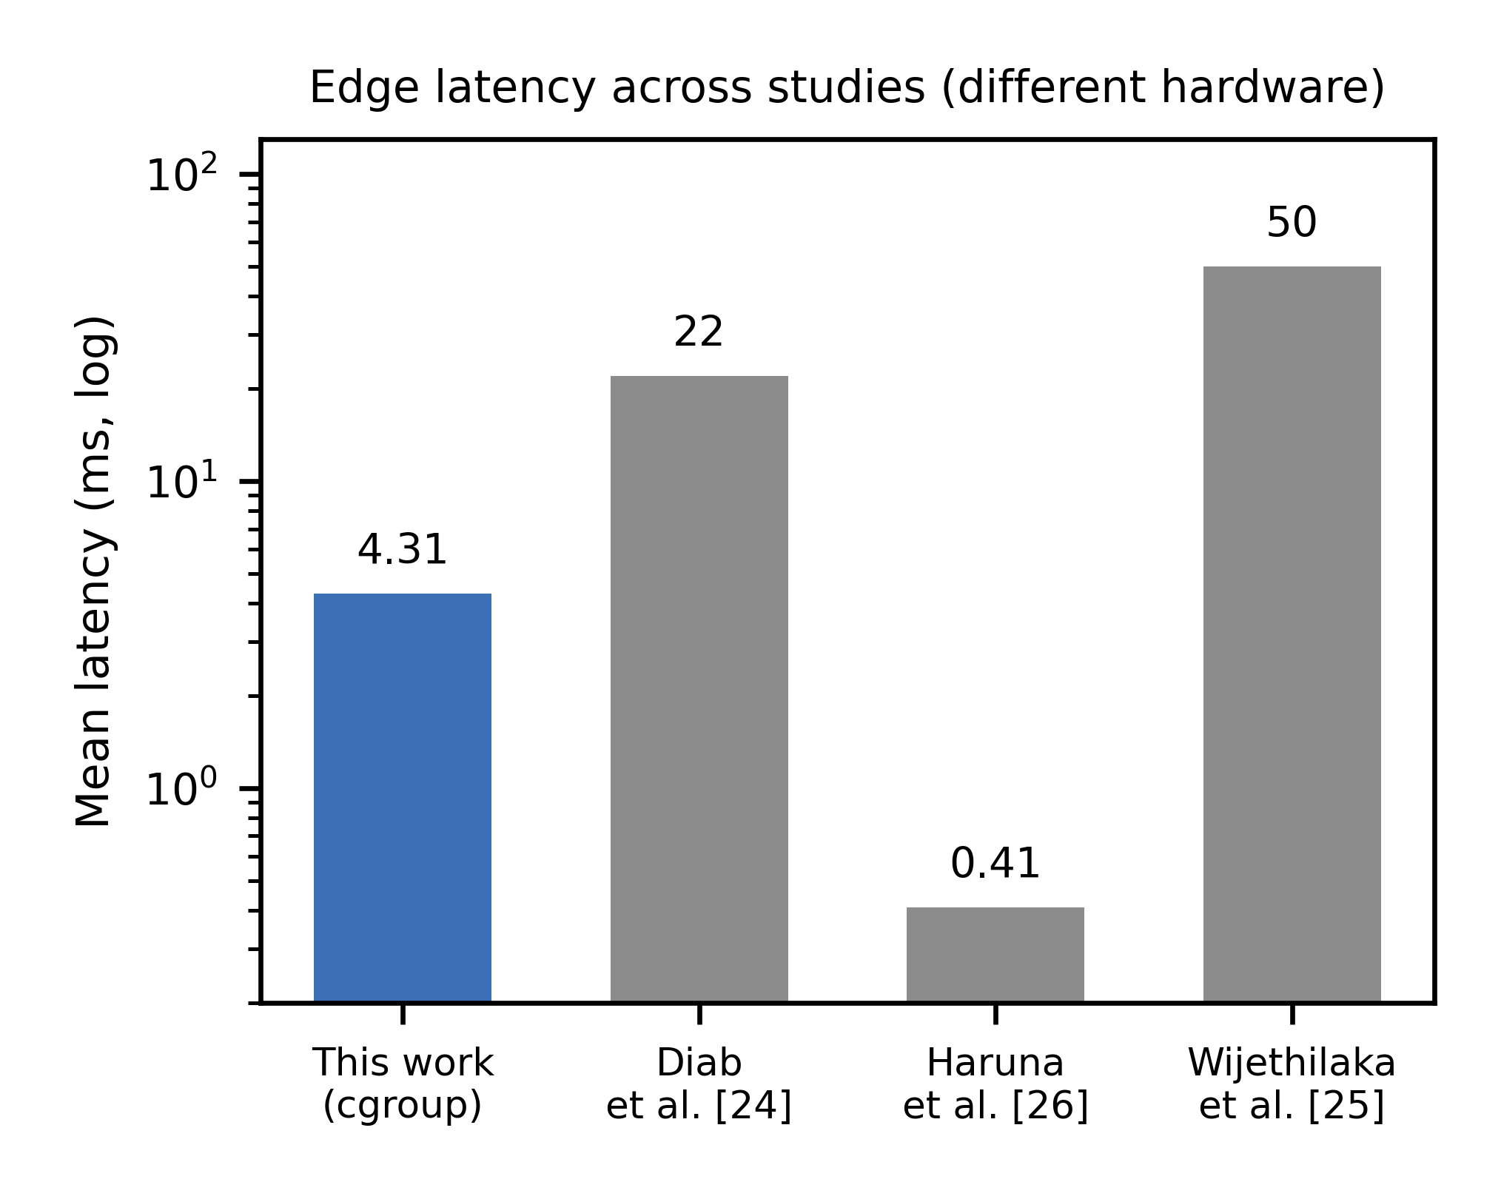
Fig. 7. Edge inference latency across studies (log scale).

6. Conclusion and Future Work
Using a single model that is jointly-trained on a shared canonical schema is not just an operational convenience over two domain-specific models — it is actually stronger than a specific, mechanistically-understood failure mode (sign-inverted feature-outcome relationships across domains) that can cause naive domain-specific transfer to invert instead of being less accurate, and it outperforms two more advanced domain-adaptation baselines that was implemented and tested head-to-head rather than only cited. The model’s adversarial evasion surface is substantially larger than an initial, since-corrected analysis suggested, but a SHAP-attribution drift monitor built from explanations already computed for interpretability flags the resulting evaded traffic as a batch-level distributional shift by a wide margin, at a bounded and measured edge-deployment cost.
This work has several limitations that bound its claims and motivate future work. Instead of using actual Raspberry Pi hardware, the edge benchmark uses a cgroup-constrained proxy; the reported p95/p99 tail-latency figures specifically may contain CPU-quota scheduling artifacts of that proxy rather than reflecting bare-metal hardware behavior, which is disclosed rather than smoothed over. Since enterprise-side adversarial robustness has not been tested, it is not reasonable to assume that the evasion rates above apply to the enterprise domain. Only three black-box attack families were tested, all on IoT-domain traffic. The reported evasion rate is a lower bound rather than a proven ceiling because neither an exact MILP-based attack nor a SHAP-guided attack against the drift monitor here have been tested. Since the XGBoost hyperparameters (Section 4.2) were manually set rather than adjusted using grid or randomized search, the headline numbers do not represent the fully optimized ceiling of each model, but rather one plausible configuration. The consistent cross-domain feature-salience finding (Section 5.2) concerns shared importance, not shared direction of effect; a feature-ablation check (Section 5.2) confirms that header_len_total and byte_rate are large contributors to the A→IoT collapse but not the whole story, since a real, smaller cross-domain gap persists once they are removed. A supplementary 5-seed check for Models A/B/C (identical hyperparameters, different random seeds) found zero training-seed variance in AUC/F1 to four decimal places, because the XGBoost configuration uses no row or column subsampling (subsample = colsample = 1.0), making the fit deterministic given the data; bootstrap confidence intervals therefore already capture the only source of uncertainty this configuration has, unlike the 5-seed DANN+OSVM treatment, whose neural-network training is genuinely stochastic. Finally, the “one model instead of two” operational argument remains narrative rather than quantified against the real cost of maintaining two domain-specific models in production. Future work should prioritize: validating the edge benchmark on physical Raspberry Pi hardware; identifying what drives the residual cross-domain gap that remains even after removing the two flagged mismatched features (Section 5.2); extending adversarial evaluation to the Enterprise domain and testing SHAP-guided and physically-realizable (inter-feature-consistent) adversarial attacks against both the classifier and the drift monitor; re-calibrating the drift-monitor threshold against a larger pool of null batches and extending its evaluation to a larger number of shift batches; running a hyperparameter search for Models A/B/C to establish a fully-tuned performance ceiling; and measuring the operational cost of a two-model deployment against the single pooled model proposed here, to make the deployment argument in Section 5.6 concrete rather than narrative.

References
[1] I. Sharafaldin, A. H. Lashkari, and A. A. Ghorbani, "Toward generating a new intrusion detection dataset and intrusion traffic characterization," in Proc. Int. Conf. Inf. Syst. Secur. Privacy (ICISSP), 2018, pp. 108–116, doi: 10.5220/0006639801080116.
[2] E. C. P. Neto, S. Dadkhah, R. Ferreira, A. Zohourian, R. Lu, and A. A. Ghorbani, "CICIoT2023: A real-time dataset and benchmark for large-scale attacks in IoT environment," Sensors, vol. 23, no. 13, Art. no. 5941, Jun. 2023, doi: 10.3390/s23135941.
[3] S. Layeghy and M. Portmann, "Explainable cross-domain evaluation of ML-based network intrusion detection systems," Comput. Electr. Eng., vol. 108, Art. no. 108692, May 2023, doi: 10.1016/j.compeleceng.2023.108692.
[4] S. Layeghy, M. Baktashmotlagh, and M. Portmann, "DI-NIDS: Domain invariant network intrusion detection system," Knowl.-Based Syst., vol. 273, Art. no. 110626, Aug. 2023, doi: 10.1016/j.knosys.2023.110626.
[5] R. Elangovan, D. D. Parthasarathy, M. Jawahar, P. Kaliyaperumal, B. Balusamy, S. Yogarayan, and V. Venkatesan, "Cross-dataset temporal and semantic generalization of intrusion detection models for the future internet," Future Internet, vol. 18, no. 4, Art. no. 194, Apr. 2026, doi: 10.3390/fi18040194.
[6] M. Cantone, C. Marrocco, and A. Bria, "Machine learning in network intrusion detection: A cross-dataset generalization study," IEEE Access, vol. 12, pp. 144489–144508, 2024, doi: 10.1109/ACCESS.2024.3472907.
[7] J. Vitorino, I. Praça, and E. Maia, “SoK: Realistic adversarial attacks and defenses for intelligent network intrusion detection,” *Computers & Security*, vol. 134, Art. no. 103433, 2023, doi: 10.1016/j.cose.2023.103433.
[8] M. Pawlicki, S. Szelest, R. Kozik, and M. Choraś, "SHAP insights into domain adaptation in netflow-based network intrusion detection powered by deep learning," in Proc. Int. Conf. Availability, Rel. Secur. (ARES), 2025, pp. 292–309, doi: 10.1007/978-3-032-00644-8_18.
[9] B. Nugraha, A. V. Jnanashree, and T. Bauschert, "A versatile XAI-based framework for efficient and explainable intrusion detection systems," Ann. Telecommun., vol. 80, pp. 1095–1120, Sep. 2025, DOI:10.1007/s12243-025-01118-9.
[10] A. Tziouvaras, B. Bertalanič, G. Floros, K. Kolomvatsos, P. Sarigiannidis, and C. Fortuna, "A representation learning approach to feature drift detection in wireless networks," IEEE Trans. Emerg. Top. Comput., 2025, DOI:10.1109/TETC.2025.3644604.
[11] D. Slack, S. Hilgard, E. Jia, S. Singh, and H. Lakkaraju, "Fooling LIME and SHAP: Adversarial attacks on post hoc explanation methods," in Proc. AAAI/ACM Conf. AI, Ethics, Soc. (AIES), Feb. 2020, pp. 180–186, DOI:10.1145/3375627.3375830.
[12] M. Wang, K. Zheng, Y. Yang, and X. Wang, "An explainable machine learning framework for intrusion detection systems," IEEE Access, vol. 8, pp. 73127–73141, 2020, DOI:10.1109/ACCESS.2020.2988359.
[13] S. Barrett, G. Dorai, L. Li, and S. Rajaganapathy, "FADES: Adaptive drift estimation via conformal signals for streaming intrusion detection," Electronics, vol. 15, no. 10, Art. no. 2114, May 2026, DOI:10.3390/electronics15102114.
[14] A. Kantchelian, J. D. Tygar, and A. Joseph, "Evasion and hardening of tree ensemble classifiers," in Proc. 33rd Int. Conf. Mach. Learn. (ICML), 2016, pp. 2387–2396.
[15] M. Rajhans and V. Khawarey, "Beyond gradient-based attacks: Adversarial robustness and explainability stability in cybersecurity classifiers," arXiv preprint arXiv:2607.01679, Jul. 2026, DOI:10.48550/arXiv.2607.01679.
[16] M. Andriushchenko, F. Croce, N. Flammarion, and M. Hein, "Square attack: A query-efficient black-box adversarial attack via random search," in Proc. Eur. Conf. Comput. Vis. (ECCV), Aug. 2020, pp. 484–501, DOI:10.1007/978-3-030-58592-1_29.
[17] J. Chen, M. I. Jordan, and M. J. Wainwright, "HopSkipJumpAttack: A query-efficient decision-based attack," in Proc. IEEE Symp. Secur. Privacy (SP), May 2020, pp. 1277–1294, DOI:10.1109/SP40000.2020.00045.
[18] R. Kazoom, Y. Ratzabi, E. Rothstein, and O. Hadar, "Boundary on the table: Efficient black-box decision-based attacks for structured data," arXiv preprint arXiv:2509.22850, Sep. 2025, doi: 10.48550/arXiv.2509.22850.
[19] B. Sun, J. Feng, and K. Saenko, “Return of frustratingly easy domain adaptation,” in *Proceedings of the Thirtieth AAAI Conference on Artificial Intelligence*, vol. 30, no. 1, 2016, pp. 2058–2065, doi: 10.1609/aaai.v30i1.10306.
[20] B. Sun and K. Saenko, “Deep CORAL: Correlation alignment for deep domain adaptation,” in *Computer Vision – ECCV 2016 Workshops*, vol. 9915, 2016, pp. 443–450, doi: 10.1007/978-3-319-49409-8_35.
[21] Y. Ganin, E. Ustinova, H. Ajakan, P. Germain, H. Larochelle, F. Laviolette, M. Marchand, and V. Lempitsky, “Domain-adversarial training of neural networks,” *Journal of Machine Learning Research*, vol. 17, no. 59, pp. 1–35, 2016.
[22] M. Mahbub, M. T. Riasat, T. Hamid, S. C. Sutradhar, and M. S. A. Khan, “A minimalistic yet effective domain adaptation strategy for IoMT network intrusion detection,” *Discover Internet of Things*, vol. 6, no. 1, Art. no. 28, 2026, doi: 10.1007/s43926-026-00288-9.
[23] J. Wu, H. Dai, K. B. Kent, J. Yen, C.-Z. Xu, and Y. Wang, “Open set dandelion network for IoT intrusion detection,” *ACM Transactions on Internet Technology*, vol. 24, no. 1, Art. no. 4, 2024, doi: 10.1145/3639822.
[24] A. Diab, A. Chehade, E. Ragusa, P. Gastaldo, R. Zunino, A. Baghdadi, and M. Rizk, “Intrusion detection on resource-constrained IoT devices with hardware-aware ML and DL,” in *2025 IEEE International Conference on Emerging Trends in Engineering and Computing (ETECOM)*, 2025, doi: 10.1109/ETECOM66111.2025.11319100.
[25] R. W. K. S. Wijethilaka, K. Yapa, and D. Siriwardena, “A cost effective machine learning based network intrusion detection system using Raspberry Pi for real time analysis,” *PLOS ONE*, vol. 20, no. 12, Art. no. e0331123, 2025, doi: 10.1371/journal.pone.0331123.
[26] A. Haruna, S. I. Yusuf, and S. A. Muhammed, “Benchmarking lightweight ML models for edge-IoT botnet detection under resource constraints,” *FUDMA Journal of Sciences*, vol. 10, no. 8, pp. 13–18, 2026, doi: 10.33003/fjs-2026-1008-4882.
[27] A. Tolay, “Beyond detection accuracy: Measuring explanation cost, stability, and utility for resource-aware IoT intrusion detection,” arXiv preprint arXiv:2608.10349, 2026, doi: 10.48550/arXiv.2608.10349.
[28] S. A. Almahaqeri, M. H. Almourish, A. A. Nasser, A. S. A. Alghawli, A. A. K. Elsayed, and A. N. Alhejoj, “An optimized gradient boosting framework for IoT intrusion detection: A comprehensive evaluation on the CICIoT2023 dataset,” *Scientific Reports*, vol. 16, no. 1, Art. no. 16909, 2026, doi: 10.1038/s41598-026-47399-5.
[29] U. Ahmed, Z. Jiangbin, A. Almogren, M. Sadiq, A. U. Rehman, M. T. Sadiq, and J. Choi, “Hybrid bagging and boosting with SHAP based feature selection for enhanced predictive modeling in intrusion detection systems,” *Scientific Reports*, vol. 14, no. 1, Art. no. 30532, 2024, doi: 10.1038/s41598-024-81151-1.
[30] G. Engelen, V. Rimmer, and W. Joosen, “Troubleshooting an intrusion detection dataset: The CICIDS2017 case study,” in *2021 IEEE Security and Privacy Workshops (SPW)*, 2021, pp. 7–12, doi: 10.1109/SPW53761.2021.00009.
[31] M. Sarhan, S. Layeghy, and M. Portmann, “Towards a standard feature set for network intrusion detection system datasets,” *Mobile Networks and Applications*, vol. 27, no. 1, pp. 357–370, 2022, doi: 10.1007/s11036-021-01843-0.
[32] T. Chen and C. Guestrin, “XGBoost: A scalable tree boosting system,” in *Proceedings of the 22nd ACM SIGKDD International Conference on Knowledge Discovery and Data Mining*, 2016, pp. 785–794, doi: 10.1145/2939672.2939785.
[33] B. Schölkopf, J. C. Platt, J. Shawe-Taylor, A. J. Smola, and R. C. Williamson, “Estimating the support of a high-dimensional distribution,” *Neural Computation*, vol. 13, no. 7, pp. 1443–1471, 2001, doi: 10.1162/089976601750264965.
[34] S. M. Lundberg and S.-I. Lee, “A unified approach to interpreting model predictions,” in *Advances in Neural Information Processing Systems 30*, 2017, pp. 4765–4774.
[35] S. M. Lundberg, G. Erion, H. Chen, A. DeGrave, J. M. Prutkin, B. Nair, *et al.*, “From local explanations to global understanding with explainable AI for trees,” *Nature Machine Intelligence*, vol. 2, no. 1, pp. 56–67, 2020, doi: 10.1038/s42256-019-0138-9.
[36] M. T. Ribeiro, S. Singh, and C. Guestrin, “Why should I trust you?: Explaining the predictions of any classifier,” in *Proceedings of the 22nd ACM SIGKDD International Conference on Knowledge Discovery and Data Mining*, 2016, pp. 1135–1144, doi: 10.1145/2939672.2939778.
[37] M.-I. Nicolae, M. Sinn, M. N. Tran, B. Buesser, A. Rawat, M. Wistuba, V. Zantedeschi, N. Baracaldo, B. Chen, H. Ludwig, I. M. Molloy, and B. Edwards, “Adversarial robustness toolbox v1.0.0,” arXiv preprint arXiv:1807.01069, 2018, doi: 10.48550/arXiv.1807.01069.
[38] P.-Y. Chen, H. Zhang, Y. Sharma, J. Yi, and C.-J. Hsieh, “ZOO: Zeroth order optimization based black-box attacks to deep neural networks without training substitute models,” in *Proceedings of the 10th ACM Workshop on Artificial Intelligence and Security*, 2017, pp. 15–26, doi: 10.1145/3128572.3140448.

